Topics Guide: The Taxonomy of Control Variables
Which controls fix which problems, what goes wrong when we leave them out, and what new problems appear when a control is too closely tied to the policy variable. If you can explain each bullet in your own words and work the bias calculation, you understand the unit.

Key formulas worth remembering
Full model: Y = β₀ + β₁X₁ + β₂X₂ + β₃X₃ + ε  Naïve model: Y = b₀ + b₁X₁ + e (X₂ omitted)  Auxiliary model: X₂ = α₀ + α₁X₁ + ε₂ (omitted variable on the left)  SE of the slope ≈ residual / (n · var(X₁)) | Naïve slope = true slope + bias: b₁ = β₁ + α₁β₂  Omitted variable bias = α₁ × β₂ = (X₁ → X₂) × (X₂ → Y)  Direction of bias = sign(α₁) × sign(β₂)  Variance inflation: VIF = 1 / (1 − r²₁₂); SE of b₁ grows by √VIF

01 · Two Goals, Two Kinds of Control
- A good estimate of program impact is accurate and precise. Accurate = unbiased (no omitted variable bias). Precise = efficient (small standard errors). Separate goals with separate remedies.
- Every control predicts Y — that is what makes it a control. What sorts it into a type is its correlation with the policy variable X₁, not with Y.
- Type A: uncorrelated with X₁ (X₃). A pure predictor of Y. It explains extra variance in Y and shrinks the residual: slope unchanged, SE smaller. It buys precision (power) almost for free.
- Type B: correlated with X₁ (X₂). A competing hypothesis. It takes a share of the X₁–Y overlap: slope changes, bias removed, SE usually larger. It buys accuracy.
- Precision is a technical fix; accuracy is a claim about the world. You can hunt for Type A controls and watch the SE shrink. Type B controls come from theory — no diagnostic tells you which competing hypothesis is missing.
Which control fixes which problem
Control | Corr. with X₁? | Fixes | Slope b₁ | SE of b₁
Type A: predicts Y | no | power (precision) | unchanged | smaller
Type B: predicts Y | yes | bias (accuracy) | moves toward β₁ | usually larger
Related to X₁ but not Y | yes | nothing | unchanged | larger (pure cost)
Related to neither | no | nothing | unchanged | ≈ unchanged

02 · Omitting Controls: The Accuracy/Precision 2 × 2
 | X₃ included | X₃ omitted
X₂ included | A · unbiased & precise | B · unbiased & imprecise
X₂ omitted | C · biased & precise | D · biased & imprecise
- A is the goal; B is honest. Omitting a Type A control leaves the slope right but widens the CI — a risk of a false negative.
- C is the dangerous cell: biased with false confidence. Tight CIs around the wrong number. Small SEs, strong significance, and high R² cannot see bias. The naïve model D is also biased, but at least it advertises its uncertainty.
- Adding noise-reducing controls to a mis-specified model makes it look better without making it better. Power (precision) should be a secondary consideration to bias (accuracy).

03 · Omitted Variable Bias: Direction and Size
- Greek = truth, Latin = our guess. The full model gives β₁; the naïve model gives b₁. Bias = b₁ − β₁, which requires the truth — so we use the path diagram instead.
- Bias is the indirect effect. b₁ = direct + indirect effect; β₁ = direct effect. The naïve slope absorbs the path X₁ → X₂ → Y because it cannot tell the two routes apart.
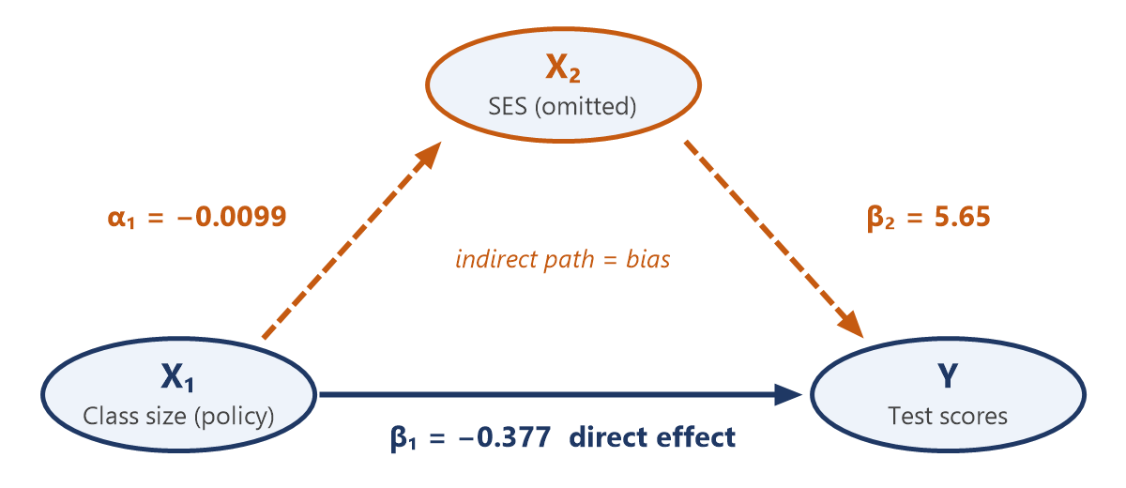
Path diagram from the class-size example (Y = test scores, X₁ = class size, X₂ = SES).
- Bias = α₁ × β₂, so both links must be open: α₁ ≠ 0 (omitted variable moves with X₁) and β₂ ≠ 0 (it affects Y). If either is zero, there is no bias. Size depends on the strength of both links; direction is the product of their signs.
Worked example (class size → test scores, SES omitted)
Step | Calculation
Naïve model | b₁ = −0.433
Full model | β₁ = −0.377, β₂ = 5.65 (SES → scores)
Auxiliary model | α₁ = −0.0099 (class size → SES)
Bias = α₁β₂ | (−0.0099)(5.65) = −0.056
Check: b₁ − β₁ | −0.433 − (−0.377) = −0.056 ✓
- Reading the example: bigger classes have lower-SES students (α₁ < 0) and SES raises scores (β₂ > 0), so the bias is negative. The naïve model makes class size look about 15% more harmful than it is (0.056 / 0.377). Omitting SES and teacher quality together overstates the impact by 51%.
Signing the bias from the path diagram
α₁ (X₁ → X₂) | β₂ (X₂ → Y) | Bias | Naïve slope b₁ is
+ | + | + | too large
− | − | + | too large
+ | − | − | too small
− | + | − | too small
- You can sign the bias from theory without measuring X₂. If the naïve slope is too large, a program can look significant when it is not; if the bias works against you, the true effect is bigger than reported. With a negative effect, “too small” means more negative — larger in magnitude.
- Bias does not shrink with sample size. It is a missing column problem, not a missing row problem.

04 · When Correlations Are Too High: Multicollinearity
- The price of fixing bias. When a Type B control is highly correlated with X₁, the circles overlap almost completely. The shared region is discarded, so b₁ is estimated from the thin slice of X₁ that varies independently of X₂.
- Standard errors inflate. SE of b₁ grows by √VIF: r = 0.5 → ×1.15; r = 0.9 → ×2.3; r = 0.95 → ×3.2; r = 0.99 → ×7.1. Real effects can lose significance (lost power).
- Slopes become unstable. With little independent variation, dropping a few cases, adding a variable, or drawing a new sample can swing b₁ and b₂ widely, even flipping signs. The model cannot decide which variable deserves the credit.
- Still unbiased. Multicollinearity is a precision problem, not an accuracy problem: right on average, noisy in any one sample.
- Warning signs: a significant model (high R², joint F-test) with individually insignificant coefficients; large changes in b₁ when X₂ is added; r(X₁, X₂) above ~0.8 or VIF above ~5–10.
- Do not drop the confounder just to shrink the SE — that trades imprecision for bias (cell C). Instead: more data, more variation in X₁ at the design stage, combine near-duplicate controls into an index, or ask whether the control measures the same thing as the policy. At r = 1 the model cannot be estimated at all.

Cheat sheet: what each specification choice does
Situation | Slope b₁ | SE of b₁
Add Type A control (uncorrelated with X₁) | unchanged | smaller
Add Type B control (correlated with X₁) | changes (bias removed) | usually larger
Omit Type A control | unbiased | larger
Omit Type B control | biased by α₁β₂ | often smaller (false confidence)
Control very highly correlated with X₁ | unbiased but unstable | much larger (× √VIF)
Control related to X₁ but not Y | unchanged | larger (pure cost)
Randomized X₁ | unbiased (α₁ = 0) | unchanged
Two questions for every control: Is it correlated with the policy variable (bias)? Does it predict the outcome (precision)?

